Q2GA: Detailed Component Flowcharts and Algorithm Pseudocode
This document complements the high-level Q2GA flowchart (Begin -> Generate Initial Population Q(t) -> Make P(t) -> Evaluate P(t) -> ... -> Update Q(t) with q-gate U(t) -> Save best individual -> loop) by zooming into each of its internal components: the quantum chromosome representation and population collapse, the reinforcement-learning (RL) observation state, the epsilon-greedy action-selection mechanism, the adaptive quantum rotation gate U(t), and the reward/Q-table update. A side-by-side comparison of the QGA (fixed-angle) and Q2GA (RL-adaptive) rotation gates is also included. Pseudocode for all four algorithms used in the comparative study (GA, SA, QGA, Q2GA) is provided in the final section.

1. Detailed Component Flowcharts

Figure 1: Master diagram -- relating the detailed figures to one Q2GA generation
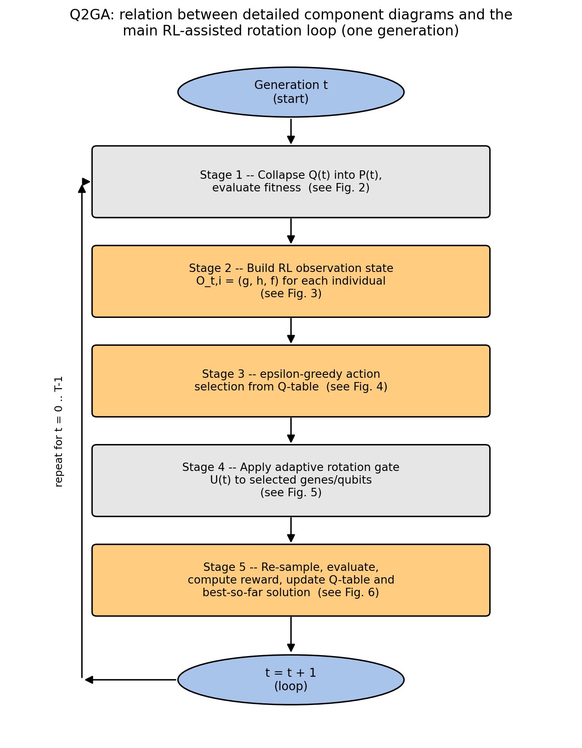
Figure 1. Master diagram -- relating the detailed figures to one Q2GA generation. (file: q2ga_master_flow.png)
This diagram shows where each of the following detailed figures fits within a single generation t of the Q2GA loop shown in the user's overview chart. Stage 1 (Figure 2) covers the collapse of the quantum population Q(t) into the real-valued population P(t) and its evaluation. Stage 2 (Figure 3) covers how each individual's RL observation state O_t,i = (g, h, f) is constructed. Stage 3 (Figure 4) covers how the RL agent selects an action (operator) using an epsilon-greedy policy over its Q-table. Stage 4 (Figure 5) covers how that action is translated into an adaptive quantum rotation gate U(t) applied to selected qubits. Stage 5 (Figure 6) covers reward computation, the Q-table update, and best-solution tracking, after which the loop advances to generation t+1. Stages 2-5 correspond to the orange RL-specific boxes in the original hand-drawn chart (Reward Calculation, Update State, Softmax/epsilon-greedy, Action Selection, Update Q(t) with q-gate U(t)).

Figure 2: Quantum chromosome representation and population collapse
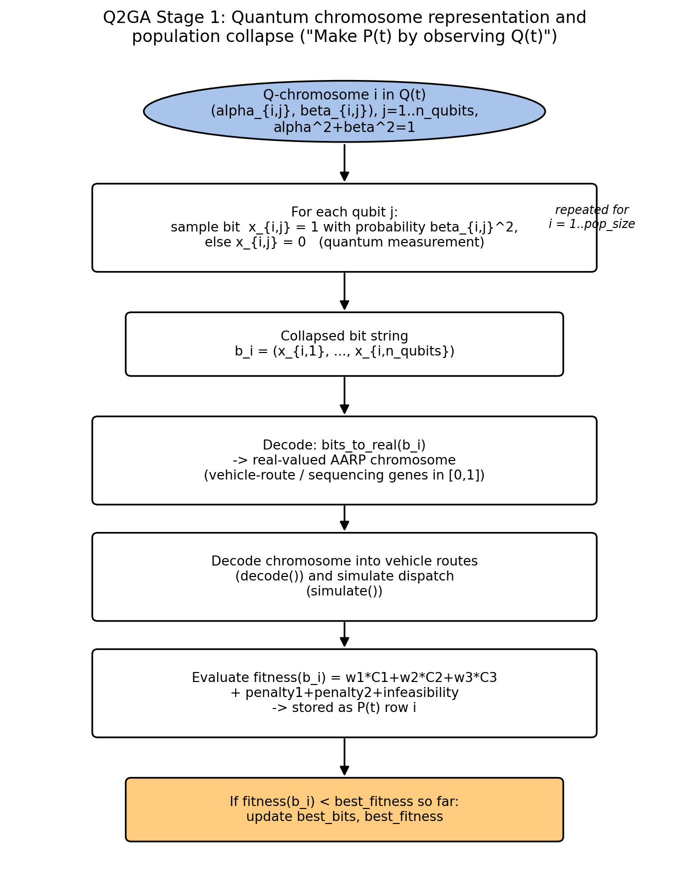
Figure 2. Quantum chromosome representation and population collapse. (file: q2ga_chromosome_collapse.png)
Each individual i in the quantum population Q(t) is represented as a string of qubit pairs (alpha_{i,j}, beta_{i,j}) for j = 1..n_qubits, with alpha^2 + beta^2 = 1, where |beta_{i,j}|^2 gives the probability of observing bit value 1 for qubit j. To form the real-coded population P(t) ("Make P(t) by observing Q(t)"), each qubit is measured independently to produce a binary string b_i, which is decoded via bits_to_real() into a real-valued AARP chromosome (vehicle-route / sequencing genes in [0,1]). This chromosome is decoded into vehicle routes and a dispatch simulation is run to compute the multi-objective fitness (weighted travel cost, response-time penalties, and infeasibility penalties). If an individual's fitness improves on the best solution found so far, the best-so-far bit string and fitness are updated -- this best-so-far record is later used by the rotation gate (Figures 5 and 7) to steer qubits toward promising bit values.

Figure 3: Construction of the RL observation state O_t,i = (g, h, f)
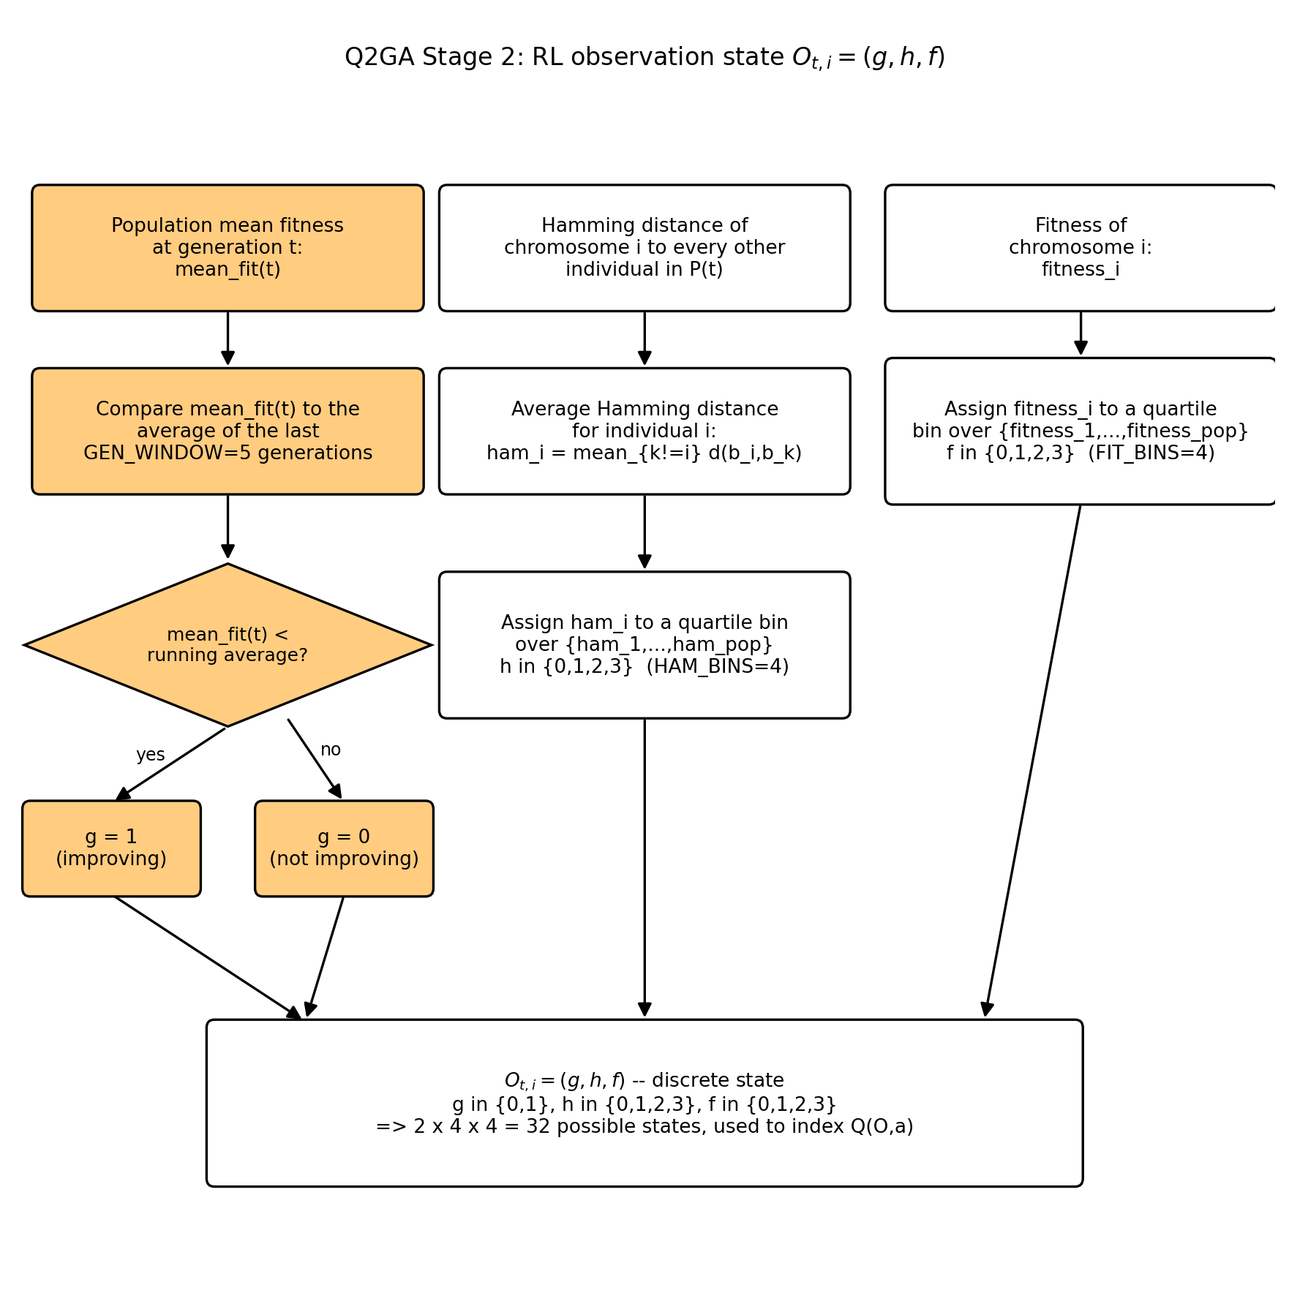
Figure 3. Construction of the RL observation state O_t,i = (g, h, f). (file: q2ga_observation_state.png)
For every individual i, the RL agent observes a discrete state O_t,i = (g, h, f) used to index its Q-table. The improvement flag g in {0,1} compares the population's mean fitness at generation t against the running average of the previous GEN_WINDOW = 5 generations: g = 1 if the population is currently improving, 0 otherwise. The diversity bin h in {0,1,2,3} is the quartile bin of individual i's average Hamming distance to all other individuals in P(t), capturing how distinct/diverse the individual is relative to the rest of the population. The fitness bin f in {0,1,2,3} is the quartile bin of individual i's own fitness within the current population. Combining these gives 2 x 4 x 4 = 32 possible observation states, each mapping to a row of the Q-table Q(O,a).

Figure 4: Epsilon-greedy action selection and mapping to operator parameters
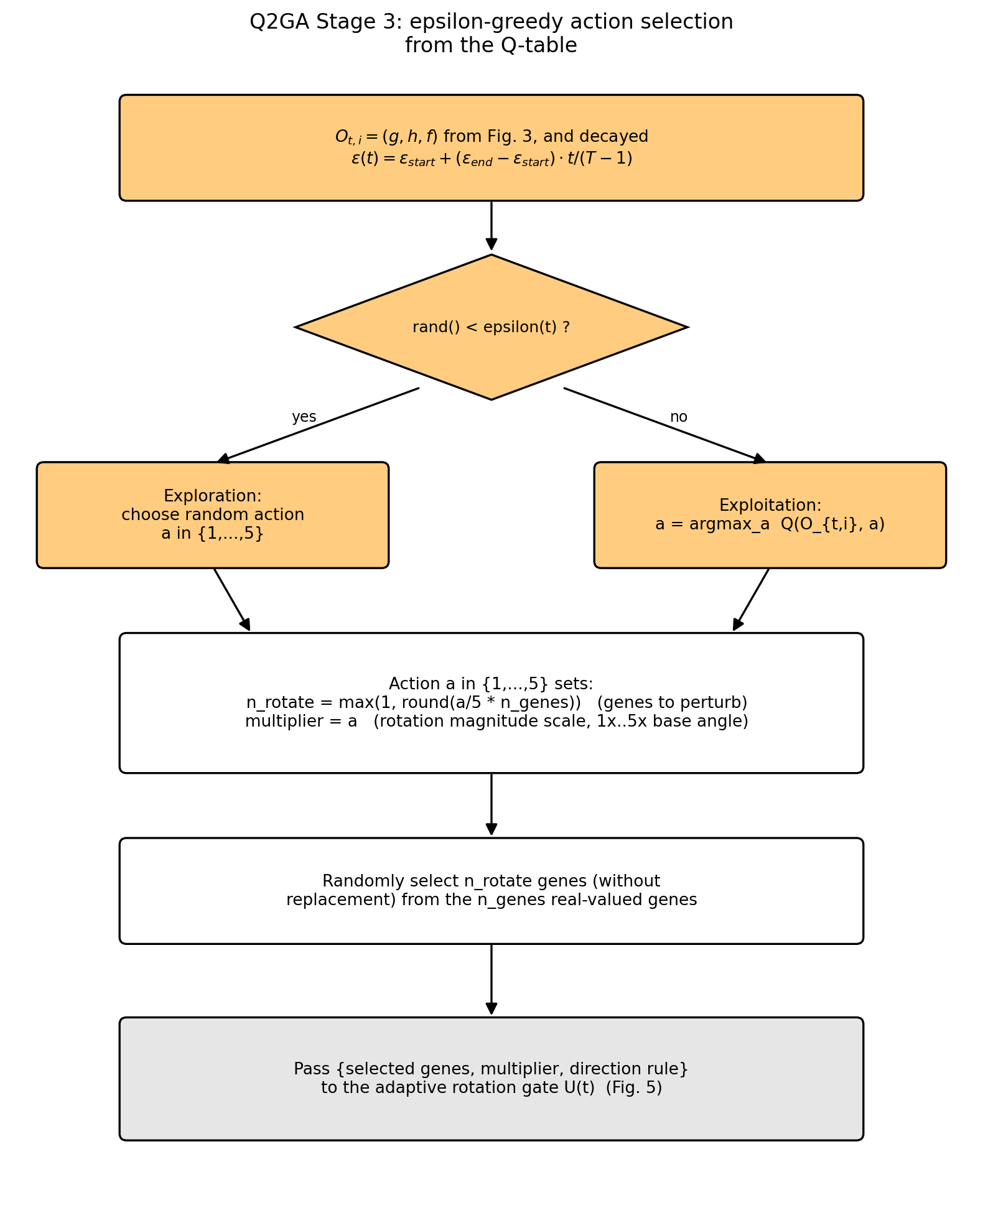
Figure 4. Epsilon-greedy action selection and mapping to operator parameters. (file: q2ga_action_selection.png)
Given the observation state O_t,i from Figure 3 and the linearly-decayed exploration rate epsilon(t) = epsilon_start + (epsilon_end - epsilon_start) * t/(T-1), the RL agent selects an action a in {1,...,5}. With probability epsilon(t) it explores by picking a uniformly random action; otherwise it exploits by choosing a = argmax_a Q(O_t,i, a). The chosen action a is then mapped to two operator parameters: n_rotate = max(1, round(a/5 * n_genes)), the number of genes (and corresponding qubits) that will be perturbed, and multiplier = a, an integer scale factor (1x to 5x) applied to the base rotation angle. n_rotate genes are then drawn at random (without replacement) from the n_genes real-valued genes of individual i, and these selections, together with the multiplier, are passed to the adaptive rotation gate U(t) described in Figure 5.

Figure 5: Adaptive quantum rotation gate U(t)
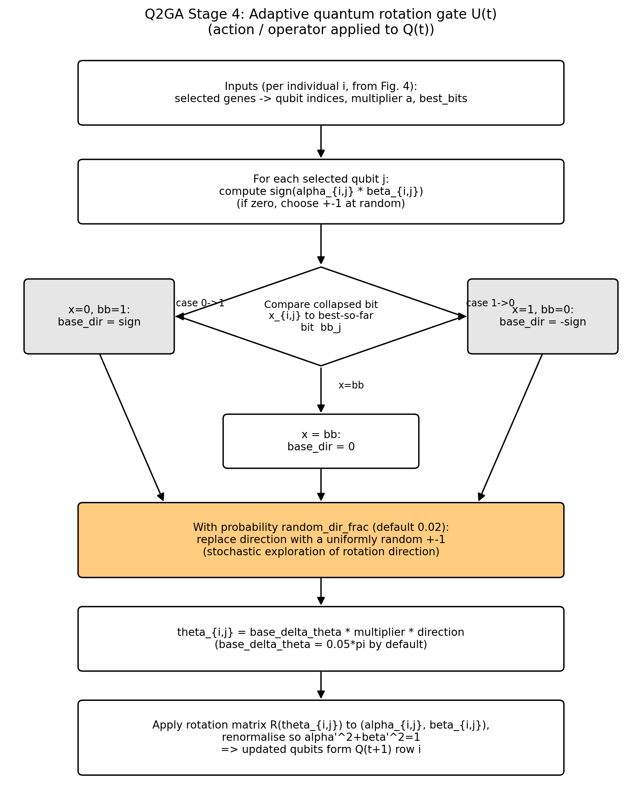
Figure 5. Adaptive quantum rotation gate U(t). (file: q2ga_rotation_gate.png)
For each qubit j selected in Figure 4, the gate first computes sign(alpha_{i,j} * beta_{i,j}) (choosing +-1 at random if the product is zero). It then compares the collapsed bit x_{i,j} to the corresponding bit bb_j of the best-so-far solution: if x_{i,j} = 0 and bb_j = 1, the base rotation direction is +sign; if x_{i,j} = 1 and bb_j = 0, the base direction is -sign; if the bits already agree, the base direction is 0. With a small probability random_dir_frac (default 0.02), this direction is instead replaced by a uniformly random +-1, injecting stochastic exploration into the rotation direction independent of the best-so-far solution. The rotation angle is then theta_{i,j} = base_delta_theta * multiplier * direction, with base_delta_theta = 0.05*pi by default and multiplier in {1,...,5} chosen by the RL agent (Figure 4). The standard 2D rotation matrix R(theta_{i,j}) is applied to (alpha_{i,j}, beta_{i,j}) and the result is renormalised so that alpha'^2 + beta'^2 = 1, producing the updated qubits that form row i of Q(t+1) -- this is the "Update Q(t) with q-gate U(t)" step in the overview chart.

Figure 6: Reward calculation and Q-table update
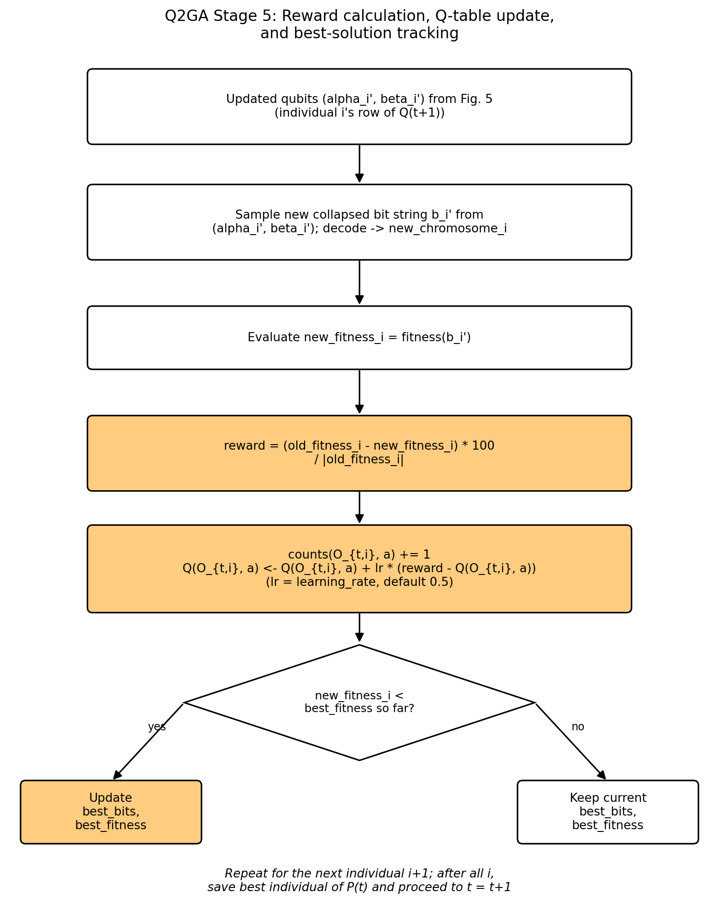
Figure 6. Reward calculation and Q-table update. (file: q2ga_reward_update.png)
After the rotation gate updates individual i's qubits (Figure 5), a new bit string is sampled from the updated qubits and decoded into a new chromosome, which is evaluated to obtain new_fitness_i. The reward is computed as reward = (old_fitness_i - new_fitness_i) * 100 / |old_fitness_i|, so a reward greater than 0 corresponds to an improvement (since fitness is minimized) and a larger magnitude reflects a larger relative improvement (or, if negative, a relative deterioration). The visit counter counts(O_t,i, a) is incremented and the Q-table entry is updated using a fixed learning-rate update Q(O_t,i, a) <- Q(O_t,i, a) + lr * (reward - Q(O_t,i, a)), with lr = learning_rate (default 0.5) if provided, or 1/counts(O_t,i, a) otherwise (a running-average update). Finally, if new_fitness_i improves on the best fitness found so far, the best-so-far bit string and fitness are updated for use in the next generation's rotation gate (Figure 5). After all individuals are processed, the best individual of P(t) is saved ("Save best individual of P(t)") and the loop proceeds to generation t+1.

Figure 7: Comparison: QGA's fixed-angle rotation gate vs. Q2GA's adaptive rotation gate
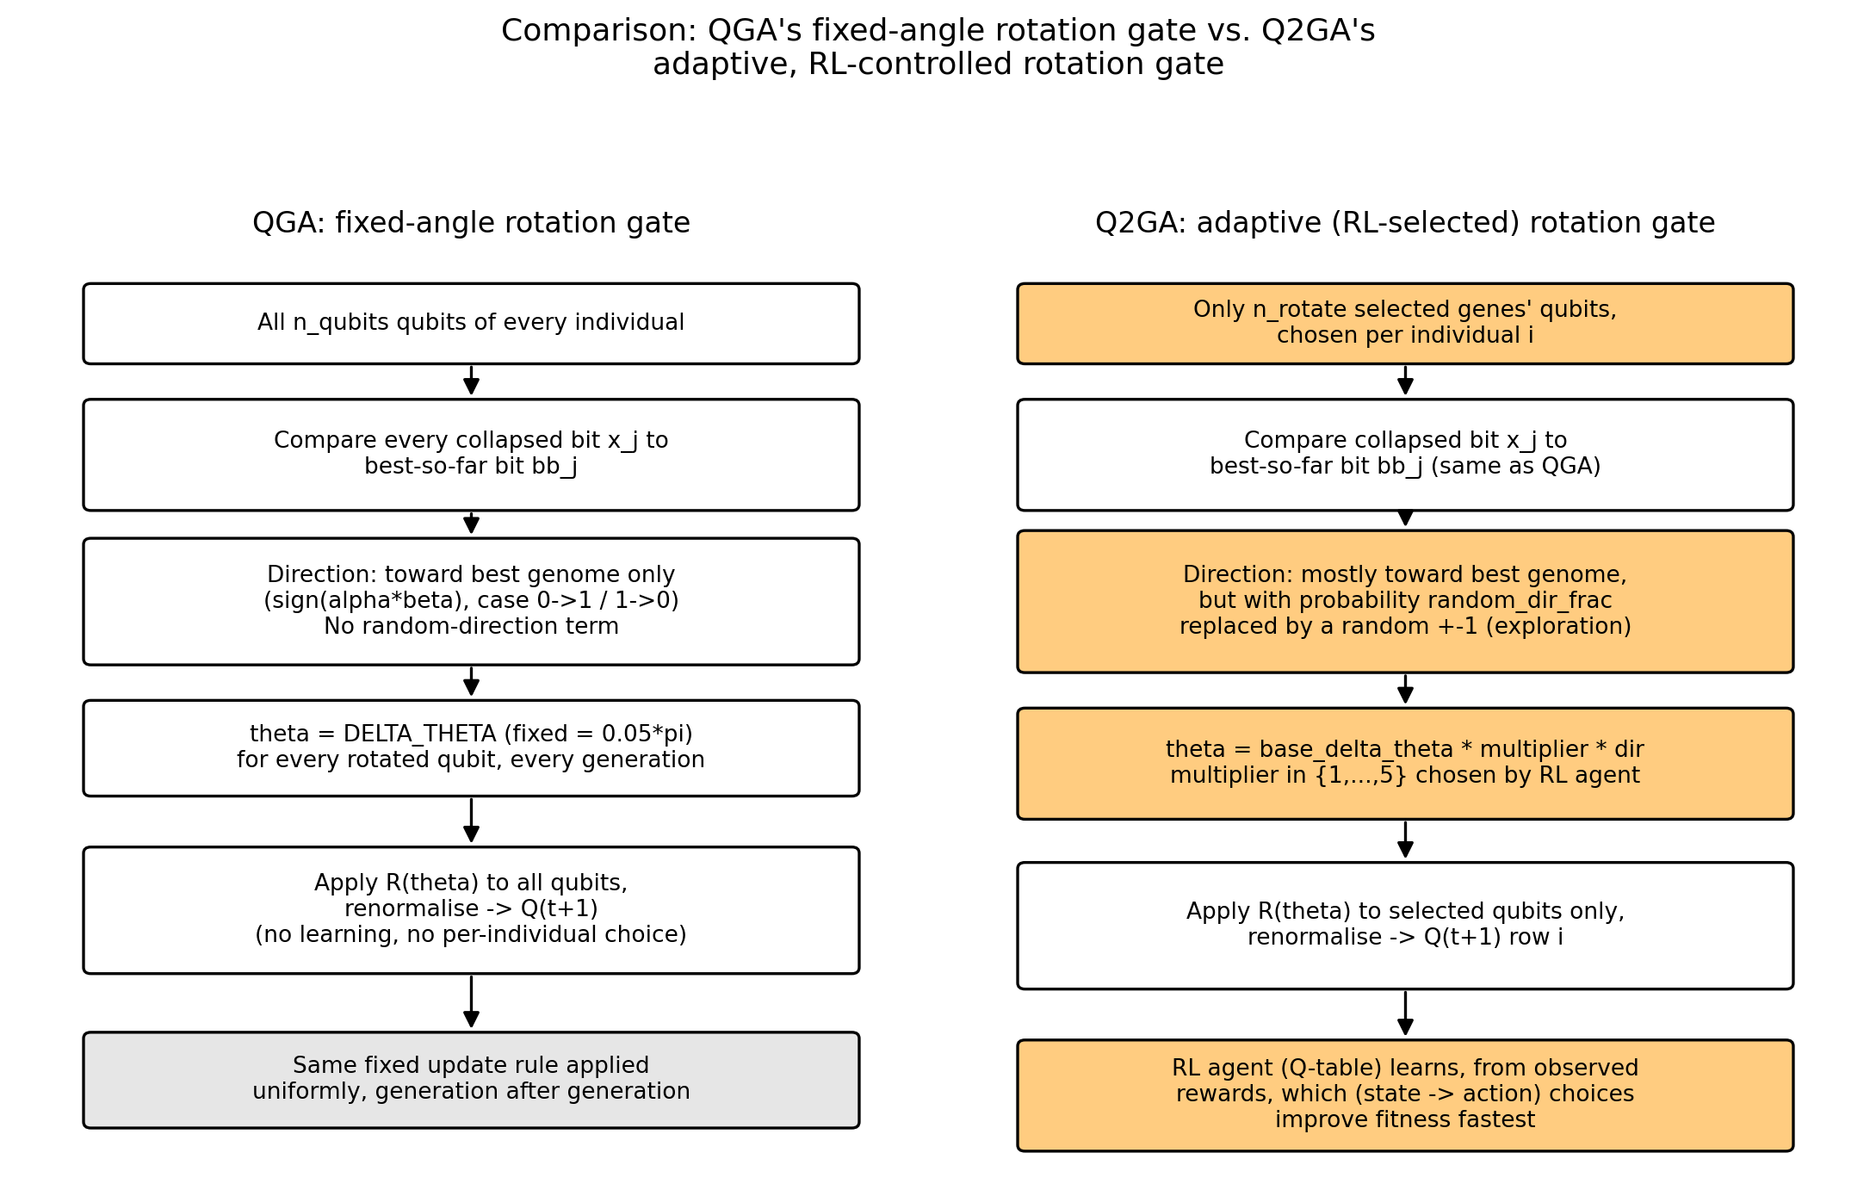
Figure 7. Comparison: QGA's fixed-angle rotation gate vs. Q2GA's adaptive rotation gate. (file: qga_vs_q2ga_rotation.png)
The QGA baseline applies a single fixed-angle rotation gate to every qubit of every individual in every generation: the rotation direction is determined purely by comparing each collapsed bit to the best-so-far genome's bits (no random-direction term), and the rotation angle is always DELTA_THETA = 0.05*pi, regardless of the individual's state or how the search is progressing. In contrast, Q2GA applies the rotation gate adaptively: only n_rotate genes' qubits (chosen per individual, based on the RL action) are rotated; the direction is usually toward the best-so-far genome but is occasionally randomized (probability random_dir_frac) for exploration; and the rotation magnitude is scaled by an RL-selected multiplier in {1,...,5}. Over many generations, the Q-table learns which (state, action) pairs -- i.e., which combinations of population-improvement trend, individual diversity, individual fitness rank, and rotation aggressiveness -- tend to yield the largest fitness improvements, allowing Q2GA to adapt its search intensity and direction in a way that the fixed-angle QGA cannot.

2. Algorithm Pseudocode
The pseudocode below reflects the actual implementations in src/algorithms/ for the four algorithms compared in this study: the real-coded Genetic Algorithm (GA), Simulated Annealing (SA), the Quantum Genetic Algorithm (QGA, fixed-angle rotation), and the proposed RL-assisted Quantum Genetic Algorithm (Q2GA, adaptive rotation).

2.1 Genetic Algorithm (GA)
Algorithm GA(pop_size, n_genes, T, pc, pm, eta=15, elitism=2)
Initialize population P(0): pop_size real-coded chromosomes in [0,1]^n_genes
Evaluate fitness(x) for all x in P(0)
best <- individual with minimum fitness in P(0)
for t = 0 to T-1 do
Sort P(t) by fitness; carry the top `elitism` individuals to P(t+1) unchanged
while |P(t+1)| < pop_size do
parent1 <- Tournament(P(t), k=3) // pick best of 3 random individuals
parent2 <- Tournament(P(t), k=3)
with probability pc:
(child1, child2) <- SBX_Crossover(parent1, parent2, eta=15)
else:
(child1, child2) <- (parent1, parent2)
child1 <- Mutate(child1, pm); child2 <- Mutate(child2, pm)
clip child1, child2 to [0,1]^n_genes
add child1, child2 to P(t+1)
Evaluate fitness(x) for all x in P(t+1)
if min fitness in P(t+1) < fitness(best): best <- argmin individual
record best fitness for generation t
return best, history

2.2 Simulated Annealing (SA)
Algorithm SA(pop_size, n_genes, T, T0=10.0, alpha=0.97, sigma=0.15)
Initialize population P(0): pop_size real-coded chromosomes in [0,1]^n_genes
Evaluate fitness(x) for all x in P(0)
best <- individual with minimum fitness in P(0)
Temp <- T0
for t = 0 to T-1 do
for k = 1 to pop_size do // pop_size perturbation trials per "generation"
x <- P(t)[k]
n_flip <- random integer in [1, max(2, n_genes // 5)]
x' <- copy of x with n_flip randomly chosen genes perturbed by
Gaussian noise (mean 0, std = sigma), clipped to [0,1]
if fitness(x') < fitness(x):
accept: x <- x'
else:
accept x <- x' with probability exp( -(fitness(x') - fitness(x)) / Temp )
(Metropolis criterion)
P(t)[k] <- x
P(t+1) <- P(t)
Temp <- Temp * alpha // geometric cooling
if min fitness in P(t+1) < fitness(best): best <- argmin individual
record best fitness for generation t
return best, history

2.3 Quantum Genetic Algorithm (QGA, fixed-angle)
Algorithm QGA(pop_size, n_qubits, n_genes, T, DELTA_THETA = 0.05*pi)
Initialize Q(0): pop_size individuals, each n_qubits qubit pairs
(alpha_{i,j}, beta_{i,j}) = (1/sqrt(2), 1/sqrt(2)) for all i, j
best_bits <- None; best_fitness <- +infinity
for t = 0 to T-1 do
// -- Make P(t) by observing Q(t) --
for each individual i:
for each qubit j: sample x_{i,j} = 1 w.p. beta_{i,j}^2, else 0
b_i <- (x_{i,1}, ..., x_{i,n_qubits}); chrom_i <- bits_to_real(b_i)
fitness_i <- evaluate(chrom_i)
if fitness_i < best_fitness: best_bits <- b_i; best_fitness <- fitness_i
// -- Update Q(t) with fixed-angle rotation gate --
for each individual i:
for each qubit j = 1..n_qubits:
s <- sign(alpha_{i,j} * beta_{i,j}) (random +-1 if zero)
if x_{i,j} = 0 and best_bits_j = 1: direction <- +s
elif x_{i,j} = 1 and best_bits_j = 0: direction <- -s
else: direction <- 0
theta <- DELTA_THETA * direction
(alpha_{i,j}, beta_{i,j}) <- R(theta) * (alpha_{i,j}, beta_{i,j})
renormalize (alpha_{i,j}, beta_{i,j})
record best_fitness for generation t
return best_bits, best_fitness, history

2.4 RL-assisted Quantum Genetic Algorithm (Q2GA)
Algorithm Q2GA(pop_size, n_qubits, n_genes, T, N_ACTIONS=5,
base_delta_theta = 0.05*pi, random_dir_frac = 0.02,
epsilon_start, epsilon_end, learning_rate,
GEN_WINDOW = 5, HAM_BINS = 4, FIT_BINS = 4)
Initialize Q(0): pop_size individuals, each n_qubits qubit pairs
(alpha_{i,j}, beta_{i,j}) = (1/sqrt(2), 1/sqrt(2)) for all i, j
Initialize Q-table Q(O,a) <- 0 for all 32 states O and a in {1,...,5}
Initialize counts(O,a) <- 0
best_bits <- None; best_fitness <- +infinity
mean_fit_history <- empty list

for t = 0 to T-1 do
epsilon(t) <- epsilon_start + (epsilon_end - epsilon_start) * t/(T-1)

// -- Stage 1: Make P(t) by observing Q(t); evaluate --
for each individual i:
sample b_i from (alpha_i, beta_i); chrom_i <- bits_to_real(b_i)
old_fitness_i <- evaluate(chrom_i)
if old_fitness_i < best_fitness: best_bits <- b_i; best_fitness <- old_fitness_i
mean_fit(t) <- mean(old_fitness_i over i)
g <- 1 if mean_fit(t) < average(mean_fit_history[-GEN_WINDOW:]) else 0
append mean_fit(t) to mean_fit_history

// -- Stage 2: build observation O_t,i = (g, h, f) for each individual --
for each individual i:
ham_i <- mean_{k != i} HammingDistance(b_i, b_k)
h_i <- quartile_bin(ham_i over all individuals; HAM_BINS bins)
f_i <- quartile_bin(old_fitness_i over all individuals; FIT_BINS bins)
O_i <- (g, h_i, f_i)

// -- Stages 3-5: per individual, select action, rotate, reward, learn --
for each individual i:
// Stage 3: epsilon-greedy action selection
if rand() < epsilon(t):
a <- random action in {1,...,N_ACTIONS}
else:
a <- argmax_{a'} Q(O_i, a')
n_rotate <- max(1, round(a / N_ACTIONS * n_genes))
multiplier <- a
selected_genes <- n_rotate genes sampled without replacement

// Stage 4: adaptive rotation gate U(t)
for each qubit j corresponding to a selected gene:
s <- sign(alpha_{i,j} * beta_{i,j}) (random +-1 if zero)
if x_{i,j} = 0 and best_bits_j = 1: direction <- +s
elif x_{i,j} = 1 and best_bits_j = 0: direction <- -s
else: direction <- 0
with probability random_dir_frac: direction <- random choice in {-1, +1}
theta <- base_delta_theta * multiplier * direction
(alpha_{i,j}, beta_{i,j}) <- R(theta) * (alpha_{i,j}, beta_{i,j})
renormalize (alpha_{i,j}, beta_{i,j})

// Stage 5: reward calculation and Q-table update
sample b_i' from updated (alpha_i, beta_i); chrom_i' <- bits_to_real(b_i')
new_fitness_i <- evaluate(chrom_i')
reward <- (old_fitness_i - new_fitness_i) * 100 / |old_fitness_i|
counts(O_i, a) <- counts(O_i, a) + 1
lr <- learning_rate if learning_rate is not None else 1 / counts(O_i, a)
Q(O_i, a) <- Q(O_i, a) + lr * (reward - Q(O_i, a))
if new_fitness_i < best_fitness: best_bits <- b_i'; best_fitness <- new_fitness_i

Save best individual of P(t)
record best_fitness for generation t

return best_bits, best_fitness, history, Q

